Name ______________________________________________ 8- M N E Date _________
Life Science MCAS Review Quiz

_____ 1. Which of the following is a main function of the cell wall?
- to store carbohydrates for later use
- to give the cell a rigid structure
- to package proteins for export
- to carry out photosynthesis

_____ 2. A diagram of a cell is shown below.
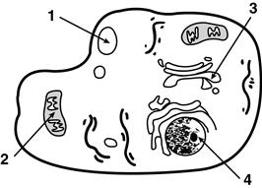

If the cell needs energy, which part has to function?
- Part 1
- Part 2
- Part 3
- Part 4

_____ 3. Some cells, such as human nerve and muscle cells, contain many more mitochondria than do other cells, such as skin cells. Why do some cells have more mitochondria than others?
- The cells use more energy.
- The cells store more nutrients.
- The cells divide more frequently.
- The cells breakdown proteins.

_____ 4. What is the main function of the chloroplasts in plant cells?
- to keep the cell rigid
- to produce glucose
- to make the cell divide
- to allow the plant to reproduce

_____ 5. Which of these could only be found inside a plant cell?
- Nucleus
- Chloroplast
- Mitochondria
- Cytoplasm

_____ 6. A euglena is a photosynthetic microorganism that moves by making whip-like motions with its long flagellum.
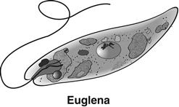
Which of these is a response to an external stimulus?
- motion of the flagellum
- size of the chloroplast
- production of glucose
- movement toward light

____ 7. Which of the following organisms has the simplest cellular structure?
- bacterium
- earthworm
- mushroom
- sunflower

_____ 8. Each of the illustrations below shows either a prokaryotic cell or a eukaryotic cell. Each cell is numbered.
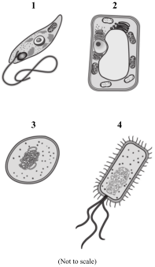
Which two cells should be classified as prokaryotic cells?
- 1 and 2
- 1 and 3
- 2 and 4
- 3 and 4

_____ 9. The table below provides information about nutrition and cellular structure for organisms in different kingdoms.
Kingdom | Nutrition | Nucleus | Unicellular or  Multicellular
Fungi | heterotrophic | yes | unicellular and  multicellular
Plant | autotrophic | yes | multicellular
Animal | ? | ? | ?

What information best completes the table?
- autotrophic, no, unicellular
- autotrophic, yes, multicellular
- heterotrophic, no, unicellular
- heterotrophic, yes, multicellular

_____ 10. Prokaryotes are structurally simple organisms that have existed for over two billion years. Which of the following are prokaryotes?
- Bacteria
- Fungi
- Plants
- Protists

_____ 11. Which of the following statements describes a way in which plant cells and animal cells are similar?
- Both types of cells are prokaryotic.
- Both types of cells are autotrophic.
- Both types of cells have cell walls.
- Both types of cells contain mitochondria.

_____ 12. A cell is shown in the diagram below.
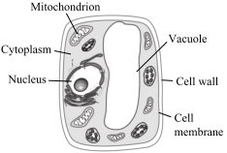
Which of the following cell characteristics provides evidence that this cell comes from a plant and not from an animal?
- A large vacuole
- A nucleus
- Mitochondrion
- A cell membrane
_____ 13. A scientist discovered a new organism in some caves in Pennsylvania. The organism has the following characteristics:
- It is multicellular.
- Its cells lack cell walls.
- It has a nucleus
- It is heterotrophic.
Based on this information, to which kingdom does the organism belong?
- Animal
- Eubacteria
- Fungi
- Plants

_____ 14. Which of the following organisms is
eukaryotic, multicellular, and autotrophic?
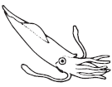
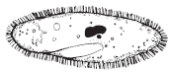

- C.

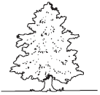
- D.

_____ 15. The organisms shown below are both found in aquatic environments.
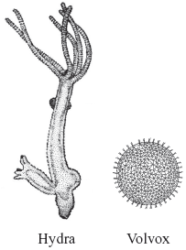
Which of the following is common to both of these organisms?
- They contain blood
- They contain nerves
- They are producers of food
- They are composed of cells

_____ 16. A unicellular organism is best described as being
- a complex organism.
- a microorganism.
- an organism with specialized cells.
- an organism with different types of tissues.

_____ 17. The diagram below shows a cell.
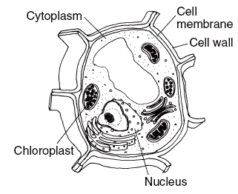
Where would this cell most likely be found?
- frog
- leaf
- mushroom
- yeast

Match the name of the organelle to the diagram:

_____21. nucleus

_____ 22. chloroplast

_____ 23. vacuole

_____ 24. cell wall

_____ 25. mitochondria

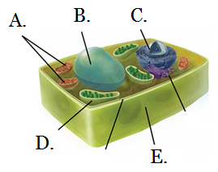

_____ 18. Which of these is an organism that is unicellular?
- amoeba
- mushroom
- ant
- seaweed

_____ 19. Which of these must be absorbed by animal cells in order to grow?
- genes
- sunlight
- nutrients
- chromosomes

_____ 20. If a new organism were discovered, which of the following would most likely be used to classify it into the appropriate kingdom?
A. the color of the organism
B. the organism’s natural habitat
C. the structure of the organism’s
anatomy
D. the location where the organism
was found

