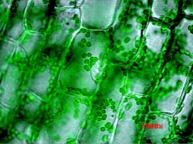
Name____________________________________________________Date_______________________Div____________
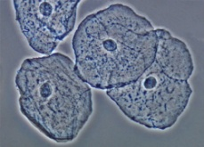
Parts of the Cell
Directions: Use your book (Yellow Cells and Heredity Book- Looking Inside Cells: Pages 23-31) to help fill in this graphic organizer about the parts of a cell. Make note of which parts are only in plant cells and which parts are in both plant and animal cells.
1. Start by defining organelle: _______________________________________________________________________
__________________________________________________________________________________________________
Organelle | What it does  (Describe) | What it looks like  (Draw) | In a plant cell? | In an animal cell?
Cell Wall
Cell Membrane
Nucleus

Organelle | What it does  (Describe) | What it looks like  (Draw) | In a plant cell? | In an animal cell?
Cytoplasm
Mitochondria
Chloroplasts
Vacuoles
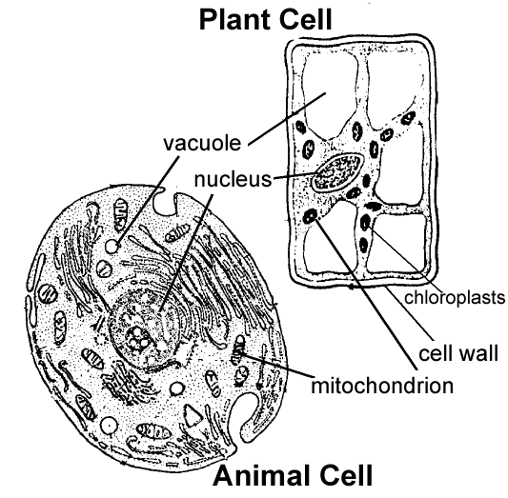
Cytoplasm
Cell Membrane

